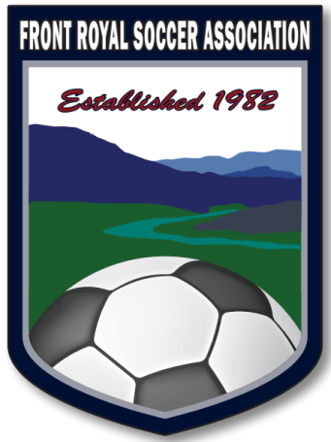
FRONT ROYAL SOCCER ASSOCIATION, INCORPORATED 214 EAST JACKSON STREET FRONT ROYAL, VA 22630
Dear FRSA Supporter and Potential Sponsor:
Front Royal Soccer Association has been promoting and organizing soccer in Front Royal and surrounding areas since 1982. For over 40 years, FRSA has been run completely by dedicated volunteers, who managed over 1000 youth soccer players in a soccer year. We are a 501(c) (3) Public Charity, so all donations are tax deductible under section 170 of the Internal Revenue Code. By sponsoring FRSA, you are demonstrating your support for the local community, and your business will receive exposure to an important and large demographic, families with school-age children. Your support will allow us to keep our fees low, pay for our soccer fields, practice fields, use of the concession stand, VYSA Insurance fees, and referees, as well as waiving fees for needy families.
We can’t do it without YOU, our Sponsors!
Cost per player to successfully run FRSA $97.00 per player
Fall 2025 and Spring 2026 Registration Fee - $70.00 per player
Separate Uniform Cost: $60.00
(Beginning in Fall 2021 – FRSA went to a two (2) uniform system.
Away and Home uniforms will be needed and purchased by parents for each player)


Sponsorships start as low as $70.00
Sponsorship Levels
Skyline Field Sponsor - $10,000
- Payment Options:
  - 5 years at $2000 each year
  - 4 years at $2500 each year
(A field is defined as one of the plateau areas at Skyline Soccerplex separated by drainage gullies – Fields will have one (1)U14 / U19 full size game field, one (1) to two (2) U12 game fields, two (2) U10 game fields, or four (4) U6-U8 game fields.)
- Field named for Sponsor– includes logo signage (2’x 4’ Di-Bond sign with bottom 4 inches reserved for field #/Age group identification) identifying the field in place during spring (Late March-Early June) and fall (Late August – Early November) seasons.
- Goal Banners (2)
- Feather Flag
- Tear Drop Flag for Designated Field
- Custom Corner Flags for their field of play (4)
- Organization name/logo with link displayed on the website for duration of sponsorship (39555 views last year)
- Team sponsorship with Thank You plaque and team picture
- Company Logo on Concession Stand TV
Royal Sponsor - $750 Yearly
- Organization name/logo on a 2’x4’ Di-Bond sign displayed at the fields during games for two seasons
- Teardrop Flag
- Team Sponsorship with Thank You plaque and team picture
- Two (2) Corner Flag-randomly placed on any field
- Organization name/logo with link displayed on the website for 1 year (39555 views last year)
- Company Logo on Concession Stand TV

Team Sponsor - $350 Yearly
- Team Sponsorship
- Tear Drop Flag
- One (1) Corner Flag-randomly placed on any field
- Thank You, plaque, with team picture
- Organization name/logo with link displayed on the website for 1 year (39555 views last year)
- Company Logo on Concession Stand on TV
Send Logo to registrar@frontroyalsoccerassociation.onmicrosoft.com

OTHER WAYS TO BECOME A SPONSOR
WEB Sponsor - $100 Yearly
- Organization name/logo with link displayed on the website for 1 year (39555 views last year)
PLAYER Sponsor - $70 per season / $140 Annually
UNIFORM Sponsor - $60 per player
PATRONS PLEDGE – Any Amount
  - Name will be mentioned on Concession Stand ‘s TV

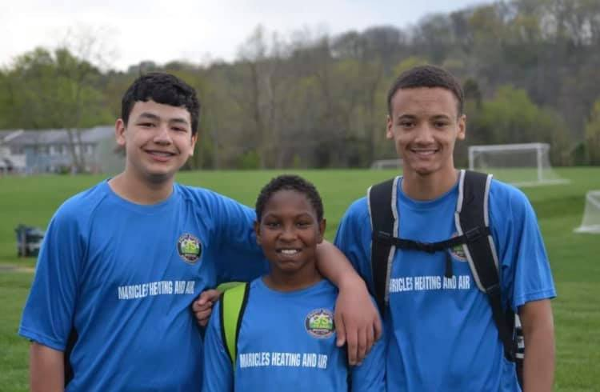
Teammates and Friends made on the field are friends forever!
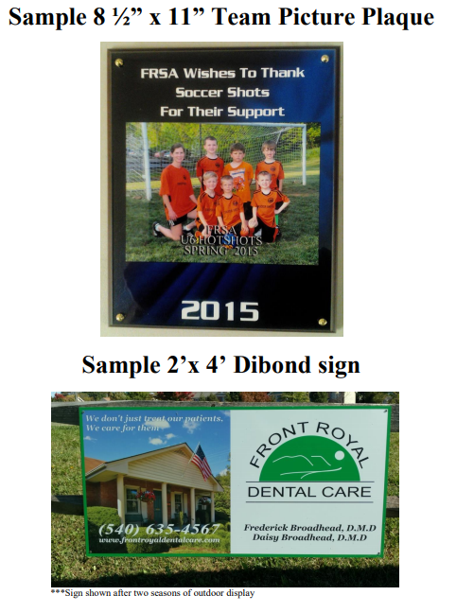
Flag Samples:  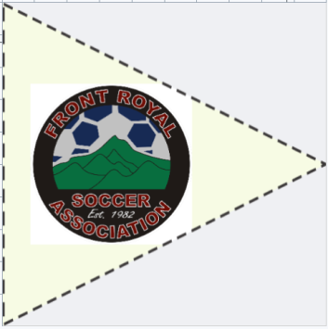 
Feather Flag Corner Flag Teardrop Flag
Thank You for your continuing support of FRSA – Front Royal Soccer Association.
PLEASE use the attached application, or sign up online at www.frontroyalsoccer.com
Contact ANY FRSA Board Member for information
Or Contact
Rob DeMariano

frsasponsor@gmail.com
FRSA Office - 540-635-2966

This form and payment can be mailed to:
FRONT ROYAL SOCCER ASSOCIATION ATTN: Sponsorships 214 East Jackson Street Front Royal, Virginia 22630
Applications are due:
SPRING Season by Feb 28th and for FALL Season by July 31st

Thank You for your continuing support of FRSA – Front Royal Soccer Association.
PLEASE use the attached application, or sign up online at www.frontroyalsoccer.com

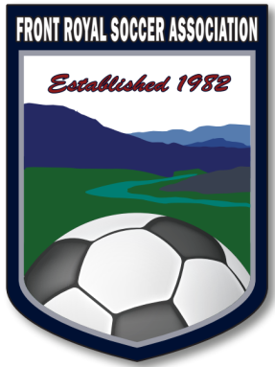
Sponsorship Application
Sponsoring Organization Name: ___________________________________________________ (As you would like to see it appear on website)
ADDRESS: _____________________________________________________________________
PHONE NUMBER: _______________________________________________________________
CONTACT PERSON: _____________________________________________________________
E-MAIL: ______________________________________________________________________
WEBSITE: ____________________________________________________________________
SPONSORSHIP LEVEL (Circle One):
Skyline Field ($10,000.00) __ / Royal ($750.00) ___ / Team ($350.00) ____
Website ($100.00) __ / Player($70/$140) ____ / Uniform($60) ____
Patrons Pledge (Any Amount) _____

SPECIAL REQUESTS: Team Name_________________________________________
Team Coach_________________________________________
Player to Sponsor_____________________________________

Thank You again for your continued support of FRONT ROYAL SOCCER ASSOCIATION!!!!!

